Pure Effect – Core Gameplay

Table of contents

Gameplay basics 5

Team Goals 5

Individual Gameplay 5

In-battle Rewards/Individual Goals 5

Gameflow – Team Perspective 6

Phases 6

Phase diagram 6

Phase 1 – The charge 7

Story Boards 7

Phase 2 – Hull Assault 9

Storyboards 9

Phase 3 – Stealth Assault 10

Storyboards 10

Phase 4 – Spec-op Assault 10

Reflection Note: Position in the battlefield vs tactical advantage 11

Gameflow Summary 11

Roles 12

Primary Roles 12

Stealth Roles 12

Spec-ops Roles 12

Commander Role outline 12

Spec-ops Role 13

Gunner Role Outline 13

Role flowchart 14

Stealth role: Counter measure operative (CM-Op) 14

Spec-ops role: Grenadier 14

Bomber pilot 14

Role flowchart 15

Stealth role: Pilot 15

Spec-ops rocket marine 15

Fighter pilot 15

Role flow chart 16

Stealth Role: co-pilot 16

Spec-ops role: machine gunner 16

Stealth Operation 17

The Assault 17

Stage1 17

Stage 2 17

Battlefield Focus 17

Dying and Respawning 18

Dying 18

Respawn points 18

Conditional Table for respawning 18

Commander Gameplay 18

Phase 1 19

Phase 2 19

Phase 3 19

Commander Abilities table 20

Main Cannon 20

Anti-Spacecraft Battery 20

Recall Praetorians 20

Stealth Operation 21

Gunner Objective 21

Bomber Objective 21

Fighter Objective 21

Collective Objective 21

Deploy Minefield 21

Deploy Stealth Mine Torpedoes 21

Deploy Droneswarm 21

Gunner Gameplay 22

Bomber Gameplay 22

Fighter pilot gameplay 22

Hand Weapons and devices 22

Weapons 22

Plotted teleporter 22

Tumbling balls 22

Stealth Mine Torpedoes 22

Superhomingspaceviper missile 22

Jawbreaker missile 23

Shieldbreaker missile 23

Drones 23

Score System 23

Conditions, Rewards and promotions 23

Gunner Reward table 24

Bomber pilot reward table 24

Fighter pilot reward table 24

Relative Combat strength tables 25

Bomber and Fighter 25

Batteries 25

The Mothership 25

The Bridge 25

Shields 25

The Bomb Room 26

The Fight Pit 26

Staff 26

Soldiers 26

Batteries 26

Guns 26

The main cannon 27

Abilities table 27

Launch Cannons 27

Hull 27

Spacecraft 28

Bombers 28

Abilities table 28

Fighters 28

Abilities table 28

Stealthcraft 28

Abilities table 28

Guns and batteries 28

Main Gun 28

Batteries 28

Guns 28

Abilities table 28

Commander AI 28

Keywords and explanations in alphabetical order 28

Leftovers: –TB Moved or Removed 30

Directional Reward Table (to be iterated) 30

General BattleLayout 30

• Spec-ops rifleman 32

# Gameplay basics

* The core game mode of Pure Effect will revolve around space combat and ship to ship and soldier to soldier combat; both taking place in a first person perspective.
* In this situation, two teams have fulfilled some condition that brings them to combat with one fully staffed mothership each.
* The base setup for a match like this involves 6 players and a commander on each team. (The commander might be an AI as well as a person.
  + NOTE! The number of players is a potential optimization issue
* The players have before the match chosen their primary role; gunner, bomber pilot or fighter pilot which is permanent for the duration of the battle.
* Player organizations must also field a player in the Commander role.
* Computer organizations/NPC factions may field a Commander AI to do that role.
* All players start out in given positions found aboard the mothership
* The different spacecraft possess different capabilities, and are strong against different targets.
  + Therefore their goals may vary, and the score system should be balanced towards each role.

## Team Goals

* The ultimate goal for a match like this is to disable the enemy mothership and force the opponent into submission.
  + Alternatively force the enemy to retreat
  + Alternatively destroy the enemy mothership (should be really hard)
* The secondary, and implied goal would be to gain as high team score as possible.
  + (which is greatly achieved by forcing the enemy into submission)
  + The team who wins should always be the one with a higher score

## Individual Gameplay

* There is roughly four types of basic gameplay going on in this part of the game;
  + Spacecraft simulation –the bomber pilot and fighter pilot roles
  + Combined [FPS](http://en.wikipedia.org/wiki/First-person_shooter) and [RTS](http://en.wikipedia.org/wiki/Real-time_strategy) elements in the Commander role
  + [rail shooter](http://en.wikipedia.org/wiki/Category:Rail_shooters) – the gunner role
  + FPS – The spec-ops roles

## In-battle Rewards/Individual Goals

* To motivate and excite the players, several in-battle rewards and promotions will be given.
  + Rewards are used with care to control how the players behave.
* Motivation should be pushed further by massive feedback achieved with audiovisual effects
  + Any kind of positive feedback to the player should be used. Ideas welcome.
* Rewards may be role-dependent.
* Some rewards are given to the team as a whole and is earned by team effort
* Some rewards are given when the battle ends, these are permanent in some way and are called distinctions

# Gameflow – Team Perspective

Here you will find a short description of how a battle is thought to evolve, and a short description of the concept phases.

## Phases

* The battle will evolve in three phases for each team; Phase 1 – the charge; phase 2 – Hull assault; and phase 3 – infantry assault.
* Each phase alters the rules of the game a little for all players, but those who gained promotions must master a whole new aspect of the game.
* The teams enter the phases together as they fulfill the conditions required
  + That means the two teams aren’t necessarily in the same phase at all times.
    - In fact, they are competing to get through the phases first.
* Entering a phase unlocks abilities and new options to the players.

## Phase diagram

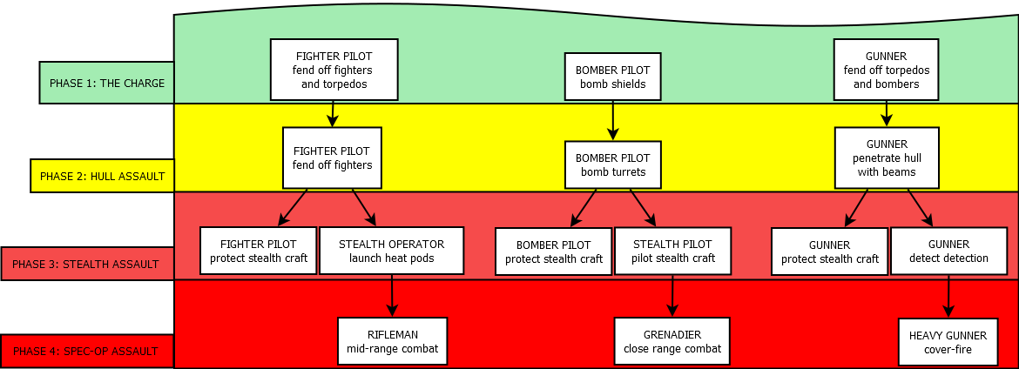

The diagram shows the evolution of player roles and what their primary goals should be during the different phases. The commander is omitted in this chart because that role is fundamentally different from the other roles.

## Phase 1 – The charge

The charge is the first phase of the battle. At this point both teams are equally matched. The following section follows chronological order.

### Story Boards

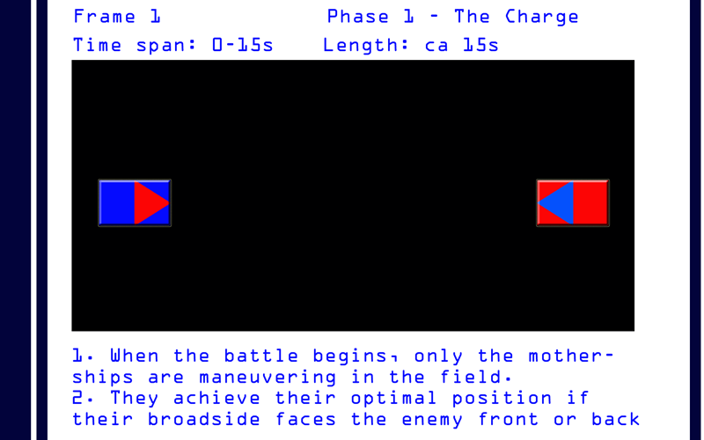

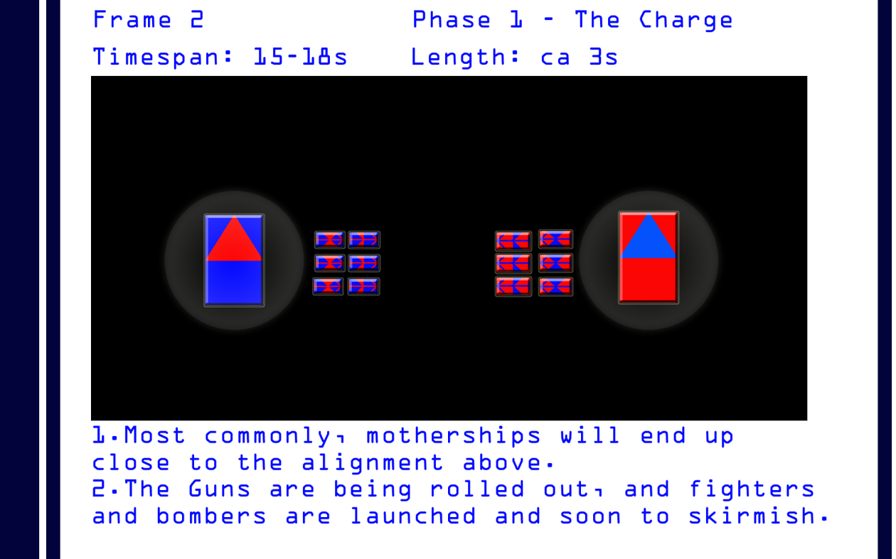

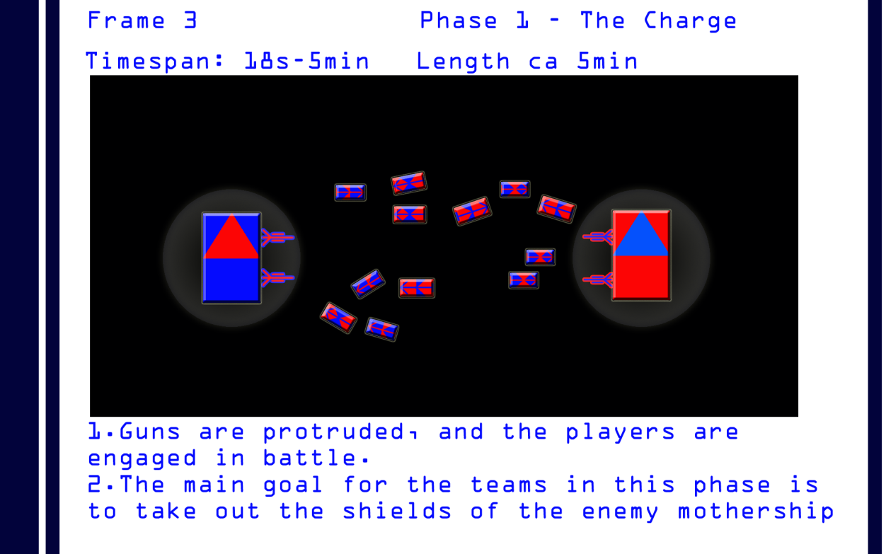

* The goal in this phase is to penetrate the enemy shields
* All spacecraft are mounted in launch cannons as the battle begins
* The arming of the guns starts immediately as the battle begins.
* Each Commander is given five seconds to launch the spacecraft before the pilots themselves are in control of launch.
  + Bombers and fighters may be launched at different locations
* When launched, Fighters and Bombers are encapsulated in a tumbling ball and all directional controls are disabled for the duration of 3 second.
  + During this period, they can arm their weapons and boost their engine.
* If timed right and the pilots enable their boost just as the tumbling ball erupts, the pilots gain a massive speed increase.
* The bomber and fighter pilots on each team should now be close to each other and the first skirmish beginning.
* Since both teams should be able to do this at approximately the same speed, they should now be in about the middle of the battlefield.
  + NOTE! The battlefield should be built so it supports this.
* The mothership or its guns may not be attacked in phase 1/before the shieldsare down
  + NOTE! That makes this phase very special for gunners(since they can’t die or be hurt and require some extra attention to create tension in their individual gameplay)- Their phase change must be dramatic.
  + NOTE! Reloading and repairing is very easy for anyone since they can do it safely behind the shields.
* No spacecraft can pass the shield of an enemy, but they can pass their own.
* This phase ends when the shield of the enemy motherships are completely destroyed. Thus the team destroying an enemy shield passes on to phase 2!

## Phase 2 – Hull Assault

The “Bare Hull” phase of the battle is announced verbally, visually and with music to both teams when one team breaches the shield of the enemy mothership. The team still in phase 1 will then know that the enemy team has progressed further than them.

### Storyboards

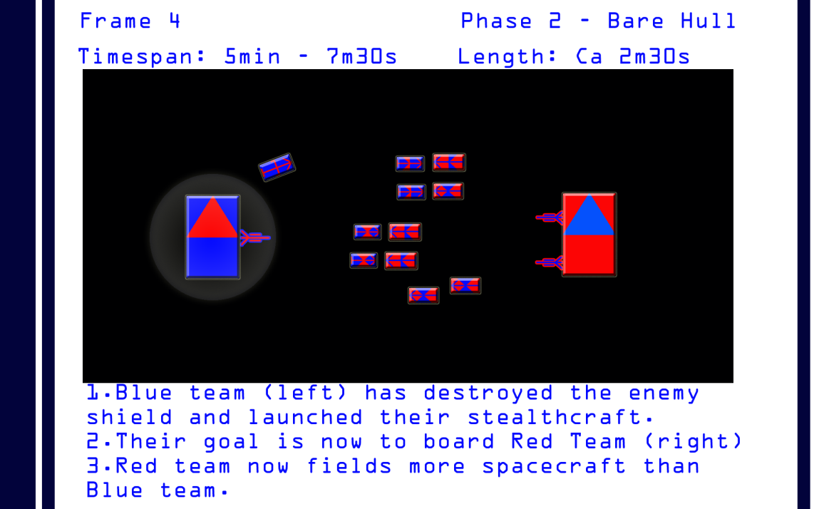

* New Commander abilities are made available.
* When the hull is bare, the Commander may launch a stealth operation.
  + That means the players take on their stealth roles
* If the stealth operation succeeds the players take on their spec-ops roles
* The team who lost their shield are now in defense, while the opposing team are offensive
* The defending team can still turn the tide by taking down the remainder of the enemy shields.
* Phase two continues until the hull of either ship is breached.

## Phase 3 – Stealth Assault

This phase too is thoroughly announced to the players, but not before the hull of either ship has been breached.

### Storyboards

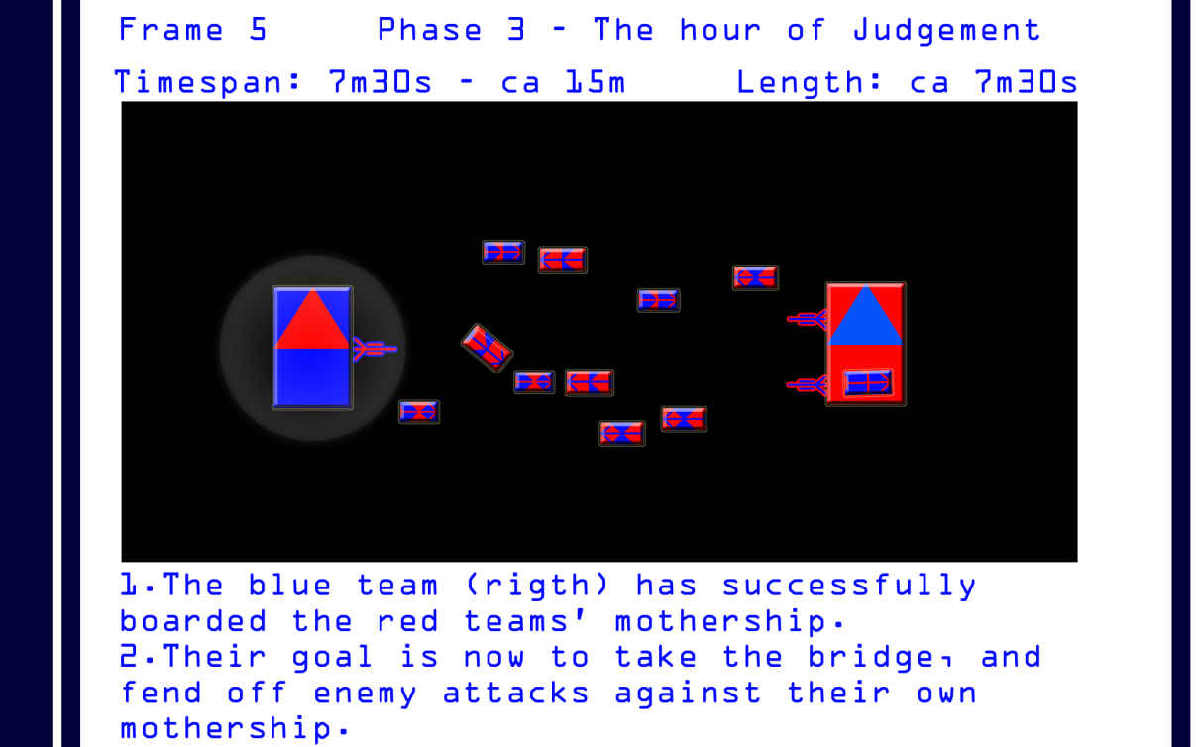

* New Commander abilities are made available.
* The Commander may still launch a [stealth operation](#_Stealth_Operation) if available, although now it will be much simpler to gain access to the enemy mothership.
* This phase continues until one team wins by fulfilling one of the following conditions;
  + One of the motherships is destroyed, in which the team in control of the remaining mothership wins.
  + One of the teams flee, an option made available when losses are cut under a defined minimum (Maybe automatic).
  + One of the teams captures the bridge of an enemy mothership, in which case they win.

## Phase 4 – Spec-op Assault

In the spec-op assault, the players who previously were in stealth roles change roles to spec-op roles.

* The roles are preset and based on what primary role the player is in.
* The goal is to take the bridge of the enemy mothership and plant a plotted teleporter device.
  + If the team fails to plant the teleporter, they can still take the bridge.
  + The teleporter may teleport support units, and make up for a place to respawn when the players die.

## Reflection Note: Position in the battlefield vs tactical advantage

* The closer the fight is to a mothership, the more support the team owning that mothership will get from their guns
* The further away the fight is from a mothership, the more fire should be allocated to the enemy mothership or its shields.
* The main cannon of motherships loose effect as they close in. It’s mainly meant for destroying the shield.

## Gameflow Summary

* In phase one the teams are at even odds and there is no FPS combat
* As one team loses its shield, the other is given an opportunity to penetrate the hull
  + This marks the beginning of phase two.
* If the hull is breached, the players can launch a stealth operation.
* If the boarding attempt is successful, some players are thrown into FPS combat aboard the enemy mothership.
* One team wins if they;
  + capture the enemy bridge
  + destroy the enemy mothership
  + forces the enemy to flee

# Roles

During the battle, a player will take on different roles. The primary role is linked to a character. The stealth roles and spec-ops roles are inherited from the primary role.

## Primary Roles

* The individual goals of the player will depend on his role in the battle.
* There are three primary roles; gunner, bomber pilot and fighter pilot, and one potential special role; Commander.
* Further the primary role will dictate how the players move around in the battleground.
* Players can be promoted for stealth roles, one exclusive to each primary role.
  + These are earned by achieving something in a battle.
* Players cannot change primary roles during battle.
  + If a player earns other roles, he always regresses to his primary role if regression happens.

## Stealth Roles

* Each stealth role has its own set of abilities for the duration of the boarding attempt.
* Roles are an important part of the in-combat reward system, and one stealth role is exclusively related to another primary role.
* Stealth roles are delegated as a result of some condition being fulfilled.
* A boarding role automatically becomes active when the Commander orders a stealth operation
  + This means a significant change in UI and control mechanics, thus gameplay, for the players involved
* A boarding attempt is successful if it deploys a plotted teleporter onto the enemy mothership.
* A boarding attempt fails if the stealthcraft is disabled/destroyed, in which case all players are returned to their Primary role as if they died.

## Spec-ops Roles

* The spec-op role takes effect as the players leave the stealthcraft to board an enemy mothership
* When in a spec-ops role, the players control an FPS character unit.
* The spec-ops role is inherited from a given stealth role
* Different spec-ops roles have different strengths for the duration of the Assault.
* The spec-op role lasts until the player is killed, and then the player respawns according to given conditions.
* ..or until the spec-ops team takes the bridge, in which case the game is over and they won.

## Commander Role outline

* The commander can observe the battle through different views.
  + The purpose of these views is to make him able to target all participants of the battle when he needs to and get an overview of the battle.
* The commander can give orders to other players through his abilities
* Following orders gives the players rewards, and influences the final score positively no matter if they win or loose
* In addition the commander controls the movement of the mothership.
  + This should be slow and cumbersome, so that this is something the commander must look into now and then, rather than keeping most of his attention.
* The commander also has direct control of a few gun/rocket/laser batteries. These should take some time to reload though, leaving the commander with time to look into other things.
* The player then controls;
  + Targeting bonuses/penalties
  + Mothership movement
  + Some offensive abilities.
* An important decision that all other players will take interest in, is when to launch the stealth operation.

### Spec-ops Role

The commander takes on his spec-ops role if he joins the spec-ops team, or the Praetorians

|  |  |  |
| --- | --- | --- |
| Primary weapon | Secondary weapon | Primary objective |
| Submachinegun | Shield emitters | Take on fire |

## Gunner Role Outline

* Gunners’ primary targets are enemy fighters and bombers and to some extent enemy torpedo’s
* Gunners are tied to the mothership.
* Guns are mounted in a way so that the gunners are able to move in all directions on a limited two dimensional area.
* The guns are able to aim in all directions in a 180 degree angle on any axis on the two dimensional area.
* All guns have a shield that can stand a certain amount of damage.
* The shield reloads over time if it is not hit.
* Guns can retract into the hull of the mothership to reload their shields, or change munitions.
* Retracting takes a certain amount of time, and proper mechanics shall prevent players from doing this too often.
* Different munitions have different bonuses or combinations of these;
  + massive damage against shields
  + massive damage against ship armor
  + massive damage against mothership hulls
  + effectively targets shields
  + effectively targets heat
  + effectively targets torpedoes
  + other options may be added

### Role flowchart

1 The arrows shows the roleprogression of Gunners

### Stealth role: Counter measure operative (CM-Op)

* Gunners may gain the countermeasure operative promotion.
* Their conditions are given in the table below.
* The counter measure operative is responsible for confusing enemy targeting systems so that they are unable to detect the stealthcraft.
* The countermeasure operative has unique abilities at his disposal

### Spec-ops role: Grenadier

* Grenadiers are armed with handheld mortars that launch grenades at the enemy.
* They have different kinds of grenades for different purposes.

|  |  |  |
| --- | --- | --- |
| Primary weapon | Secondary weapon | Primary objective |
| Grenade Mortar | Submachinegun | Shock and confusion |

## Bomber pilot

* Bombers are quite fast spaceships, but cannot quite reach the top speed of fighters. They also suffer a little in maneuverability as most of the available power is tied up to shields and forward speed.
* Their main goal in battle is to damage the enemy shields, hull and guns
* Bombers should have some ship to ship capabilities so that they are not easy targets for fighters.
* Bomber pilots can sacrifice shield strength in favor of speed and opposite.

### Role flowchart

2 The arrows shows the roleprogression of Bomber pilots

### Stealth role: Pilot

The stealth pilot gets to fly the stealthcraft. This is a special spacecraft that functions similar to a bomber, but with some exclusive features, and with transport capabilities.

* The stealth pilots goal is to get the stealthcraft as close to the enemy mothershipas possible.
* The stealthcraft has several unique abilities at disposal.

### Spec-ops rocket marine

* The spec-ops rocket marine is equipped with a rocket launcher, and a sub-machinegun.
* The rocket supply should be limited and balanced so that each rocket shot counts for something.
* They are the strongest available attack for closed quarter fighting.
* Their rockets are devastating to any target.
* Slow moving compared to projectiles, hence why they don’t work well against enemy infantry.

|  |  |  |
| --- | --- | --- |
| Primary weapon | Secondary weapon | Primary objective |
| Rocket Launcher | Submachinegun | Fortified targets |

## Fighter pilot

* Fighters are light, agile and lightning fast spaceships
* Fighters should primarily target other fighters and bombers.
* By doing a pit stop in the hangar, they can change munitions and repair during battle.
* Fighters are weak to enemy gunfire, and should avoid enemy gunfire as much as possible.
* Fighter pilots may strengthen their shield at the cost of speed and opposite.

### Role flow chart

3 The arows show the Fighter pilot role progression

### Stealth Role: co-pilot

The stealth co-pilot is responsible for jamming enemy particle beams while trying to stealth onto the enemy mothership.

### Spec-ops role: machine gunner

The spec-ops machinegunner is heavily armored and do medium damage against fortified targets and enemy soldiers. The rapid fire of the machinegun compromises precision.

|  |  |  |
| --- | --- | --- |
| Primary weapon | Secondary weapon | Primary objective |
| Rapidfire machine gun | Submachinegun | Fortified targets and soldiers |

## 

# Stealth Operation

A Commander may launch a stealth operation when theshieldsof the opposingmothershiparedown.

* The goal of a stealth operation is to let the spec-ops team gain access to the enemy mothership’s interior.
* When a stealth operation is initiated, all players with a stealth roleare instantly teleported to their seat in the stealthcraft.
* The stealth operation is over when;
  + The stealthcraft is destroyed.
  + The stealthcraft successfully penetrates the enemy hull.
  + The stealthcraft is out of tumbling balls

# The Assault

* When the Assault begins, the last phase of the battle is triggered, the hour of judgement.
* All players with a spec-op role takes part in the Assault
* The assault begins when the first player sets foot on an enemy mothership.
* The Assault can be split into two stages;

## Stage1

* The primary goal of the spec-op team is to establish a bridgehead.
  + This is done by deploying and interacting with a plotted teleporter
* Their main obstacle will be waves of enemy defenders trying to sabotage the plotted teleporter.
* The secondary goal of the spec-ops team is to take the enemy bridge.

## Stage 2

* The objective of everyone involved in the assault at this point is to take the bridge
* Soldiers other than spec-opscan now enter the enemy mothership through the teleporter

# Battlefield Focus

The battlefield focus is defines an area of the battlefield where the players gain damage bonuses. The point of the battlefield focus is to encourage a battle where the players don’t spread out too thin and far away from the mothership.

* Players gain defense bonuses when they are in the battlefield focus area.
* How battlefield focus affects the player may depend on his role
* The battlefield focus area is defined by several factors/locations
  + The X number of players being at furthest ends of the battle
  + Centre of the space in-between the motherships
  + What phase the battle is in (equal to the phase of the team with the furthest progression through he phases)

# Dying and Respawning

* Dying and Respawning is conditional, and depends on a few factors.
* A player may respawn as long as there are Clones left in the mothership.

## Dying

* A player dies if his Hit Points reaches below 0.

## Respawn points

* A respawn point is a point in a level where player characters or vehicles appear when they are brought into the game.
* When a “dead” player is brought back to life, he always starts at a respawn point.
* If several respawn points are available, the Commander or commander AI decides what spawn point to have active.

## Conditional Table for respawning

* A player respawns as long as there is a respawn point.

1 All conditions within the same cell must be fulfilled for the spawn point to be true

|  |  |
| --- | --- |
| Condition | Respawn point |
| Role: Fighterpilot | Fight Pit |
| Role: Bomberpilot | Bomb room |
| 1. Role: Fighterpilot 2. Plotted teleporter deployed | Hangar 1 or Plotted teleporter |
| 1. Role: Bomber pilot 2. Plotted teleporter deployed | Hangar 2 or plotted teleporter |
|  |  |
|  |  |

# Commander Gameplay

* Being a human commander implies being the leader of a player faction or an Alliance general
* The commander leads the battle.
* The commander sets objectives for the other players
  + Objectives are motivation for the other players to attack the objective target.
  + Objectives encourage focused team efforts.
  + When other players attack their respective objectives, they gain massive damage and/orpoint bonuses for their team.
* The commander is in direct control of the main cannon and he has to aim and fire it.
  + The main cannon are balanced towards destroying shields.
* From phase two the commander may launch a stealth operation to win the battle.
* The commander controls the movement of the mothership.
  + Routes can be set and altered
* There are different views available to make it easier to assess the situation.
  + 2D top down view
  + 2D side view
  + 3D Battlefield
  + Bridge view – seeing the battle from the windows of the bridge.
  + Pilot view – the commander may always have a look from another players’ viewpoint

## Phase 1

* In phase one, the commander must position his mothership to make ready for a stealth operation.
* By firing the main cannon as often as possible, he does significant damage to the enemy shields. (There is a margin of error here, but it should demand some skill)
* By setting objectives for the other roles, he increases their damage and/or score output, given that they follow objectives.
* By deploying mines and/or droneswarms he can increase pressure on the opposing team.
* Primarily the commander is occupied with the main cannon and positioning the ship in this phase.

## Phase 2

Actions in this phase depends on if the team has shields left or not, but the phase starts when one team lose their shield.

* If the enemy shields are down, the commander must decide whether to launch a stealth operation or not.
  + This should almost be a certainty if available.
* The commander with his shields down should;
  + Utilize his anti-spacecraft battery for what it’s worth.
  + Be vary of stealth operations
* Launching a stealth operation diverts players from the open space battle; therefore the team doing so will be at a slight disadvantage on the open battlefield, leaving the other team some room to finish off the remaining shields.
* There are two ways to breach the hull;
  + Bombers and Gunners repeatedly hit a point on it.
  + The stealth operation takes care of it
* When the hull is breached, phase three begins

## Phase 3

A team reaches this phase when they successfully land their first infantry inside the enemy hull.

* Both teams may be in phase 3 at the same time.
* If the team successfully plants the plotted teleporter, the commander must decide whether to lead the assault, defense, or the space battle.
* Leading the space battle greatly influences the outcome there.
  + The commander then takes on his spec-ops role.
* Leading the Assault greatly boosts their chance of succeeding.
* Leading the defense greatly contributes to hindering their enemy in capturing the bridge.
* As long as the commander can reach a teleporter, he can swap what part of the battle to lead.

## Commander Abilities table

|  |  |  |  |
| --- | --- | --- | --- |
| Ability name | Phase 1 – The charge | Phase 2 – Bare Hull | Phase 3 – Hull breached |
| Main Cannon | 10 sec cooldown | 10 sec cooldown | 10 sec cooldown |
| Anti-Spacecraft battery | (15 sec cooldown) but has no reach outside the shields | 15 sec cooldown | 15 sec cooldown |
| Recall Praetorians | Not available | Not available | 1 |
| Stealth Operation | Not available | 1 time limit | The whole former team must be dead |
| Gunner objective | May be used at will | May be used at will | May be used at will |
| Bomber objective | May be used at will | May be used at will | May be used at will |
| Fighter objective | May be used at will | May be used at will | May be used at will |
| Collective objective | 2 minute cooldown | 2 minute cooldown | 2 minute cooldown |
| Deploy minefield | 5 minute cooldown | Cooldown reset for mothership without shield. | As normal |
| Deploy stealth mine torpedoes | 1 available | If remaining | If remaining |
| Deploy droneswarm | 5 available | If remaining | If remaining |
| Launch cannons | 1 charge for bombers  1 charge for fighters  1 charge for stealthcraft  If not manually launched after 10 seconds of combat beginning, they are launched automatically (for bombers and fighters) | Not available | Not available |

### Main Cannon

The main cannon is the main attack available to the[Commander](#_Commander)

* It takes a certain amount of time to reload
  + Meaning it cannot be spammed, and shouldn’t take too much attention.
* The primary function of the main cannon is to destroy shields

### Anti-Spacecraft Battery

* The anti-spacecraft battery is meant to take out fighters and bombers
* Cannot reach outside the ships shields
  + Making them of little use in phase 1

### Recall Praetorians

* This ability makes all players promoted to Praetorian instantly teleport back to the mothership
* The ability is made available when the hull of the commanding officers mothership is breached.

### Stealth Operation

* Using this ability instantly launches a stealth operation
* The ability is unavailable until the whole of the spec-ops team is killed.
* The ability is always unavailable if the plotted teleporter is active.

### Gunner Objective

* To set this ability, the Commander must first target an enemy object.
  + UI feedback lets the commander know if this is a good target for gunners.
* Gunners using this as their target gain damage and score bonuses.

### Bomber Objective

* To set this ability, the Commander must first target an enemy object.
  + UI feedback lets the commander know if this is a good target for bombers.
* bombers using this as their target gain damage and score bonuses.

### Fighter Objective

* To set this ability, the Commander must first target an enemy object.
  + UI feedback lets the commander know if this is a good target for fighters.
* fighters using this as their target gain damage and score bonuses.

### Collective Objective

* To use this ability, the Commander must first target an enemy object
* Everyone attacking this object will have their damage significantly increased, and the score should be multiplied by the number of different players hitting that target.

### Deploy Minefield

* The Commander should be able to do this in any view
* Minefields can be manipulated into different shapes.
  + Different shapes will affect the battlefield in different ways.

### Deploy Stealth Mine Torpedoes

* The Commander should be able to do this in any view
* Stealth Mine Torpedoes are deployed in the same manner as a minefield, but there only a few mines in each minefield of this type.

### Deploy Droneswarm

* The droneswarm is a collection of drones
* To deploy a drone swarm, the Commander must first target an enemy object
* The drones attack that target until destroyed.

# Gunner Gameplay

# Bomber Gameplay

# Fighter pilot gameplay

# Hand Weapons and devices

## Weapons

## Plotted teleporter

The plotted teleporter is a device the players can deploy where they want, and then use as a spawn point

* The players can interact with the plotted teleporter to decrease its deployment time.
* The plotted teleporter has hitpoints, and may be destroyed.
* Damaging the teleporter influences its effectiveness

## Tumbling balls

Tumbling balls are a kind of capsule that surrounds vehicles when they are shot out of a launch cannon

* While in a tumbling ball, all directional controls are disabled
* Tumbling balls have hitpoints
* A tumbling ball may take a high amount of damage
  + While possible to destroy, tumbling balls shouldn’t be attractive targets
* A tumbling ball “erupts” X seconds after launch

## Stealth Mine Torpedoes

Stealth mine torpedoes are torpedoes deployed as mines, but with the ability to attack targets in the surrounding area

* Some system make the torpedoes able to target enemy spacecraft within a certain area in front of them, and launch towards that target
* The torpedoes are powerful enough to destroy any unshielded spacecraft.
* Torpedoes also damage shields severely

## Superhomingspaceviper missile

This missile almost never misses its target.

* This missile is intended for breaking stealth
* It does some damage to shields, and disables the enemy stealth capabilities
* It does no or little damage to enemy hull.
* It may be used on other targets than the stealthcraft

## Jawbreaker missile

This missile is intended for the hullof a mothership

* Has advanced path finding capabilities
* Can confuse enemy targeting systems
* Does massive damage against hull.

## Shieldbreaker missile

This missile targets the shield of an enemy spacecraft

* It’s targeting and damage is ineffective against enemies without a shield.
* Does some damage to enemy motherships’shields

## Drones

* Are tiny unmanned spacecraft that doesn’t have a shield
* Their behavior is controlled by an AI
* Moves in swarms using a collective target.
* One drone does little damage.
* May receive targets from the Commander.
* Finds their own target if none is set for them

# Score System

All scores are team based, and any score gained by any player is added to the team score. This is to encourage team play, and the whole score system is based on that thought.

* The score is strongly influenced by players following objectives
* Winning boosts the score significantly, maybe by a factor of x2
* Gaining promotionsadds to score

# Conditions, Rewards and promotions

The general reward table contains rewards that are available to all classes.Promotions are a type of reward.

|  |  |
| --- | --- |
| Condition | Reward |
| Player gets first kill | High damage bonus for 30 seconds |
| Player destroys the collective objective ([Commander abilities](#_Commander_Abilities_table)) | Medium point bonus for 30 seconds |
| Player has 3 kills without dying | visual announcement to teammates that the player is hot. |
| Player has 4 kills without dying | Voice and significant visual announcement to teammates that the player is on a streak. |
| Player has 5 kills without dying | Voice and massive visual announcement to all players that the current player is dominating |
| Player has most points and 5 minutes of the battle has passed | Visual and verbal announcement to all players that the player is on the leaderboard. This should be announced once every minute, but only if the standing changes |
|  |  |

## Gunner Reward table

|  |  |
| --- | --- |
| Condition | Reward |
| Player destroys the gunner objective | Medium bonus to score for 30 seconds |
| Player achieves 2 kills within 30 seconds | Countermeasure operative promotion |
| Player achieves 3 kills within 30 seconds | Countermeasure operative promotion |
| Player is first to breach the hull | Massive bonus to points for 30 seconds |
| Player destroys an enemy battery or gun | Massive damage bonus for 30 seconds |
| Detects an enemy stealth fighter | Arms the superhoming spaceviper missile |
| Destroys 10 enemy torpedo or missile | Arms the jawbreaker missile if enemy shields are down Arms the shieldbreaker missile if enemy shields are up |

## Bomber pilot reward table

|  |  |
| --- | --- |
| Condition | Reward |
| Player destroys the Bomber objectives | Medium bonus to score for 30 seconds |
| Player achieves 2 kills within 30 seconds | Stealth pilot promotion |
| Player achieves 3 kills within 30 seconds | Stealth pilot promotion |
| Player is first to breach the hull | Massive bonus to points for 30 seconds |
| Player destroys an enemy battery or gun | Massive damage bonus for 30 seconds |
| Detects an enemy stealth minefield | Arms the superhoming spaceviper missile |
| Clears an enemy minefield | Arms the jawbreaker missile if enemy shields are down Arms the shieldbreaker missile if enemy shields are up |

## Fighter pilot reward table

|  |  |
| --- | --- |
| Condition | Reward |
| Player destroys the Fighter objective | Medium bonus to score for 30 seconds |
| Player achieves 2 kills within 30 seconds | Stealth co-pilot promotion |
| Player achieves 3 kills within 30 seconds | Stealth co-pilot promotion |
| Player takes out an enemy stealth craft | Massive bonus to points for 30 seconds |
| Player clears an enemy minefield | Massive damage bonus for 30 seconds |
| Player diverts enemy homing missile to enemy mothership | Arms the superhoming spaceviper missile |
| Player destroys 10 torpedoes or missiles | Arms the laser beam |

# Relative Combat strength tables

## Bomber and Fighter

|  |  |  |  |  |  |
| --- | --- | --- | --- | --- | --- |
| VS | Batteries | Bomber | Fighter | Mothership  Shield | Mothership Hull |
| Bomber | High | Medium | Medium | High | Massive damage |
| Fighter | Medium | High | Strong | Medium | Weak |

### Batteries

|  |  |  |  |  |  |  |
| --- | --- | --- | --- | --- | --- | --- |
| Ammunition type | Batteries | Bomber | Fighter | Mothership Shield | Mothership Hull | Missiles and Torpedoes |
| Radar Flak | Weak | High | High | Medium | Weak | Medium |
| Rapidfire projectile | Weak | Weak | Weak | Massive Damage | None | High |
| Missile Artillery | Strong | Weak | Weak | Weak | Strong | weak |

# The Mothership

The mothership doesn’t classify as a spacecraft because of its multirole functionality. It is instead referred to as a space structure.

* Motherships works a lot like hangar ships in our world.
* They carry personnel and material over vast distances and contain little societies
* Motherships cannot land on planets
  + But may orbit them.
* Motherships have both battle and timeworld functionality
* Building a mothership takes significant team effort, and costs quite a lot.
* There may be different classes of motherships

## The Bridge

The bridge is the area of the ship from where the Commander gives his orders. It has no true significance outside of battle.

* If a team loses control over their bridge, they lose the battle
* If a team conquers the bridge of an enemy, they win the battle

## Shields

All motherships have shields. Shields protect against enemy attacks.

* The shields of a mothership works slightly different than the shields of spacecraft
* Enemy spacecraft, torpedoes or missiles are slowed down if caught inside a shield
* The Commander can adjust the density of the shields, and;
  + Higher density shields slows spacecraft more than lower density shields
  + Lower density shields has a further reach than higher density shields
  + At its highest density, shields should function as a solid wall to the enemy
* Shields don’t affect anything friendly, except Anti-spacecraft batteries.
* The amount of HP in the shields regulates, to a large extent, how long phase 1 should last.

## The Bomb Room

This is an area of the mothership where ships are stored.

* Hangar one contain bombers.
* There are several [spawnpoints](#_Respawn_points" \o "A respawn point is a point in a level where player characters or vehicles appear when they are brought into the game.) for bombers in a hangar

## The Fight Pit

This area is almost identical to hangar 1, but with fighters instead of bombers

## Staff

The mothership staff includes a Commander, pilots, gunners and soldiers. In addition a lot of NPC’s make up the staff.

## Soldiers

All motherships carry with them soldiers. These are mindless clones produced to function as expendable storm troops.

* Soldiers enter the battle if one of the teams successfully deploys a plotted teleporter.
  + The team being boarded gets to use them for defense
  + The boarding team gets to use the for attack
  + Soldiers are heavily armored, but only offer a moderate challenge to spec-ops
  + Soldiers react to cover fire
* Their objective is to support the spec-ops as they try to take the bridge.

## Batteries

There are three types of batteries; they all share the same cooldown;

* The anti-spacecraft battery has limited reach, and is meant for close range defense
  + The reach of the anti-spacecraft battery is equal to the reach of the shields, even if those changes
  + The anti-spacecraft battery has a close to 100% effectiveness if not lured by countermeasures
* The artillery battery is very efficient at enemy hull, but are unable to penetrate enemy shields
* The missile battery is mainly effective at enemy guns

## Guns

Guns are manned by gunner

* A gun can retract into the hull
* While retracted, the gunner can change ammo and the gun is repaired
  + Guns have limited ammo and must retract at some point to recharge
  + Guns have an energy pool for shields that are spent; this can be reloaded while retracted.
  + The more actions the player choose while retracted, the longer it takes
  + Players should be able to influence retract times, or at least have something to occupy them while the gun is retracted
* Guns have a shield with a given amount of hitpoints
* Guns have hitpoints that are separate of shields
* A gun is restricted to a two dimensional grid on the hull of the mothership

## The main cannon

The main cannon is a huge cannon made to destroy very large shields.

* This cannon is controlled and aimed by the Commander.
* The main cannon have a cooldown.

### Abilities table

|  |  |  |  |
| --- | --- | --- | --- |
| Ability name | Phase 1 – The charge | Phase 2 – Bare Hull | Phase 3 – Hull breached |
| Retract | To be used at will | To be used at will | To be used at will |
| Set ammo | Available while retracted | Available while retracted | Available while retracted |
| Preloaded firepattern | Medium Cooldown | Medium Cooldown | Medium Cooldown |
| Mark target | To be used at will | To be used at will | To be used at will |
| Activate particle beam | Not available | Cooldown | Cooldown |
| Fire stealth detect beacon |  | 1 charge | Remainder of charge from phase 2 |

## Launch Cannons

Launch cannons serve a separate role and are available only at the beginning of the battle, and in phase 2.

* There are one set of launch cannons loaded with fighters
  + When launched, ALL fighters are launched at the targeted location
* The same set of rules that go for fighters are identical for bombers
* One launch cannon is launched with the Stealthcraft
* Fighters and bombers are launched in tumbleballs

## Hull

The hull refers to the metal structure that makes up the body of the mothership.

* The hull have several points that can be damaged
  + If a point in the hull loses all its hit points, then a hole appears at that point in the hull.
* Damaging the hull counts towards the total damage of the mothership

# Spacecraft

## Bombers

### Abilities table

## Fighters

### Abilities table

## Stealthcraft

### Abilities table

# Guns and batteries

## Main Gun

## Batteries

## Guns

### Abilities table

# Commander AI

# Keywords and explanations in alphabetical order

To read the explanation for a given keyword, just hover the mouse above it

|  |
| --- |
| Key words and explanations in Alphabetical order |
| abilities |
| achieving |
| Anti-spacecraft batteries |
| bridge |
| bombers |
| bomber pilot |
| Bomb room |
| Commander |
| Commander abilities |
| Commander AI |
| conditions |
| deploying mines |
| die |
| different targets |
| drones |
| fighter pilot |
| fighters |
| droneswarms |
| Fight Pit |
| [FPS](http://en.wikipedia.org/wiki/First-person_shooter) |
| gunner |
| guns |
| hull |
| launch cannon |
| main cannon |
| mothership |
| objectives |
| phase |
| Plotted teleporter |
| point bonuses |
| primary role |
| promotions |
| [rail shooter](http://en.wikipedia.org/wiki/Category:Rail_shooters) |
| rewards and promotions |
| reward system |
| role |
| [RTS](http://en.wikipedia.org/wiki/Real-time_strategy) |
| score |
| score system |
| shields |
| soldiers |
| spacecraft |
| spawn point |
| spec-ops |
| staffed |
| stealthcraft |
| Stealth Mine Torpedoes |
| stealth operation |
| stealth roles |
| team score |
| teleporter |
| the hour of judgement |
| tumbling balls |
|  |
|  |

# Leftovers: –TB Moved or Removed

* It should then launch tumbleballs at holes in the enemy hull.
* It must then hide and return to its own mothership to reload energy
* Furthermore it should return to the enemy mothership for extraction of the spec-ops.
* Stealth crafts can launch EMP’s
* Stealth crafts can use the battering ram ability
* Stealth crafts can use the stealth ability

If the stealth pilot joins the boarding team, he functions as a tech expert.

### Directional Reward Table (to be iterated)

|  |  |  |
| --- | --- | --- |
| Primary Role | Condition | Reward |
| Gunner | First gun kill | Promoted to Countermeasure Operative |
| Fighter Pilot | First fighter kill | Promoted to Stealth Co-Pilot |
| Bomber Pilot | First bomber kill | Promoted to Stealth Pilot |
| Any | Kill commander objective for the current class | Promoted to current class Boarding Role |
| Any | Kill collective objective | Fat bonus to points earned for the next duration of X seconds |
| Bomber pilot | Destroy 2 targets within X seconds | High damage bonus for the next duration of X seconds |
| Bomber pilot | Destroy 3 targets within X seconds | Massive damage bonus for the next duration of X seconds |
| Fighter pilot | Destroy 2 targets within X seconds | High damage bonus for the next duration of X seconds |
| Fighter pilot | Destroy 3 targets within X seconds | Massive damage bonus for the next duration of X seconds |

## General BattleLayout

* A battle will evolve in three phases;
* Phase 1 – the charge – where the focus is player against player, one on one.
  + The goal is to destroy the enemy shields to progress to phase 2 – bare hull
  + The odds are even in this part of the battle, the two teams representing perfect symmetry.
  + All combat takes place in space and with spacecraft and cannons.
* Phase 2 – bare hull – where the focus is to excite one team, and to put the other on edge. In this phase, the team with the bare hull risks being boarded, thus loosing.
  + The team with the bare hull can still turn the tide of the battle by taking out the shield of the enemy mothership too.
  + In this phase, the boarding team is slightly at disadvantage in the boarding part of the battle. Taking the bridge should really be a challenge.
  + the team being boarded is slightly at disadvantage in the spacecombat outside.
  + If the boarding team successfully captures the bridge, they win.
* Phase 3 – The hour of judgment – If the game wasn’t ended in phase two, it can now be ended in one of three ways;
  + One team capturing the bridge of another, thus winning
  + One team flees, thus loosing.
  + One team destroys the enemy mothership, thus winning. This option should not occur often, but if it does, the loosing team should actually lose their mothership.

|  |  |  |
| --- | --- | --- |
| Primary weapon | Secondary weapon | Primary objective |
| Interface Mask | Submachinegun | Hack enemy systems |

### Spec-ops rifleman

* The rifleman is a trained killer who sacrifices precision to nothing. The assault rifle has three firing modes; semi-automatic, triple shot and fully automatic. He also carries 5 grenades.

|  |  |  |
| --- | --- | --- |
| Primary weapon | Secondary weapon | Primary objective |
| Rifle | Grenades/submachinegun | soldiers |